Exploratory Data Analysis

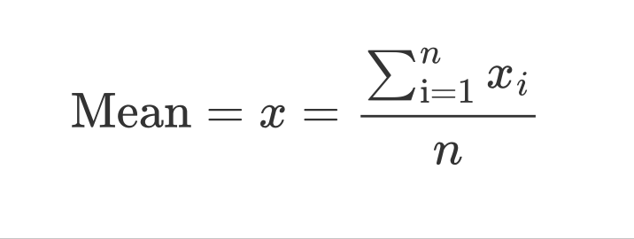

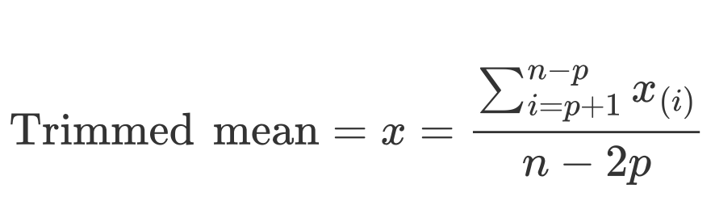

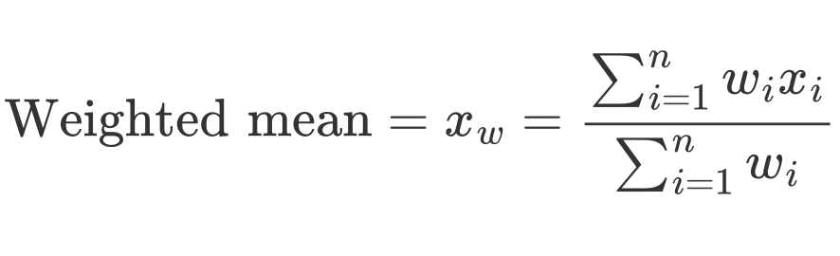

The median is the middle number on a sorted list of the data. If there is an

even number of data values, the middle value is one that is not actually in

the data set, but rather the average of the two values that divide the sorted

data into upper and lower halves.

For the same reasons that one uses a weighted mean, it is also possible to

compute a weighted median. As with the median, we first sort the data,

although each data value has an associated weight. Instead of the middle

number, the weighted median is a value such that the sum of the weights is

equal for the lower and upper halves of the sorted list. Like the median,

the weighted median is robust to outliers.